**How the construction of elevated highways came to an end**

The trend of creating elevated highways in US cities is now widely seen as having been a mistake. Such highways are now facing the axe

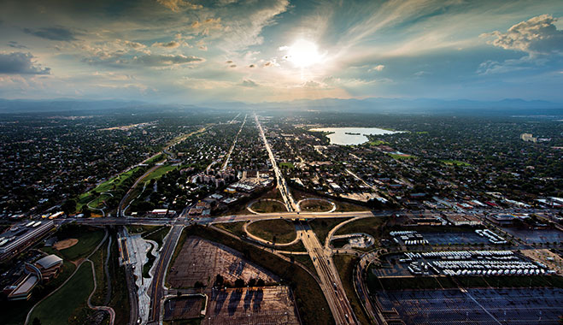

An aerial view of the Denver Interstate 70 and Sloan Lake, US. Elevated highways were constructed to help cut commuter time as more people moved away from cities, but still required decent access

[INFRASTRUCTURE](https://www.worldfinance.com/infrastructure-investment) | [PROJECT FINANCE](https://www.worldfinance.com/project-finance)

**Author:** Tom Bailey

March 1, 2016

In the now-iconic opening credits of the television show *The Sopranos*, New Jersey-based mob boss Tony Soprano makes his journey from somewhere in the dense urban jungle of New York City – presumably having been there for business reasons – to the refuge of his family home in North Caldwell, a suburb in New Jersey.

In his retreat to the ’burbs, the commuting Mafioso cuts through the second tier cities on the coast of New Jersey that face westward out to New York City. He bypasses this urban sprawl with ease, using America’s famed road network, below through bridges and – most importantly – above, on elevated highways, allowing him to drive his 1999 Chevy directly in, and out, of his place of business in the city, to his place of residence – the tranquil suburbs.

Cities began to construct highways that cut above their own urban territory, raised high above the rest of the city, connecting one end or area of the city to another

This sort of journey became a staple throughout American cities in the 20th century, as more and more Americans bought into the dream of the white picket fence home in the suburbs, yet continued to wish (or were compelled) to work in the city.

To facilitate this commute, all across American cities large elevated highways were erected, allowing for cars to swoop over the congested and supposedly crowded cities, from the suburban outskirts to the business core. Now, however, many cities across America are reassessing this trend, and in some cases reversing it, viewing the elevated highway as a mistake.

**Paved with good intentions**  
Dating back to the 1920s, one of the first of these roads was the West Side Elevated Highway in New York. However, it was in the post-war period, when car travel and America became synonymous, that their construction really took off. In 1956, President Dwight Eisenhower passed the now-famous Federal Highway Bill, which saw the construction of over 40,000 miles of modern roads, connecting America from coast to coast and everywhere in between.

While such plans had been discussed for decades, as Patrick Kennedy, a professional urban designer and co-head of the A New Dallas project, noted: “The actual implementation from a political and financial perspective really started with President Eisenhower’s frustration with the logistical challenges of moving huge armies during the First World War on small muddy roads, and then the impression and efficiency of the German autobahn system during the Second World War. He desired to create a national interstate system primarily for national defence purposes.”

Yet while the original plan was to connect different regions of the country, bringing together cities and towns, local and city governments around the country had other ideas. Increasingly, cities began to construct highways that cut above their own urban territory, raised high above the rest of the city, connecting one end or area of the city to another.

Such constructions, however, would often require the displacement of existing communities, or bring a number of inconveniences to urban residents left behind, such as noise or air pollution, unwanted shadows, as well as the loss of urban public space – generally seen as lowering the quality of life of residents. Valuable land, upon which residents could live, work and meet, would be lost to the highways, hollowing out city cores.

The reasons why city bureaucrats would want such imposing, elevated highways to cut across the urban landscape were numerous. The idea of highways looming over the cityscape itself has its roots – as with much controversy in 20th century urban planning and architecture – in the thinking of the Swiss architect Le Corbusier.

As Anthony Flint wrote in his book *Wrestling with Moses: How Jane Jacobs Took on New York’s Master Builder and Transformed the American City*: “Just as he streamlined form in his architecture, Le Corbusier has a grand vision for streamlining the city.

His concept of Ville Contemporaine and later the Ville Redieuse, or ‘Radiant City’, called for razing older sections of the city that been had built up randomly over time, to be replaced by dozens of cruciform high-rise towers in open plazas that could accommodate millions… All functions of life, like shopping or work, were to be strictly separated into distinct zones… Highways would be necessary to connect the various elements, and they would be elevated, directly serving buildings above the ground floors.”

Connected to this was the idea that elevated highways could result in urban renewal. As Kennedy noted: “Local governments could take the federal money, provided the states matched 10 percent of the total cost, and build the highways as they saw fit with little oversight.” The resulting construction would also provide thousands of jobs for the city.

**End of the road**  
However, as quickly as the movement for elevated highways took off, opposition arose. As Nicole Gelinas, a contributing editor of *City Journal*, told *World Finance*, skepticism toward elevated highways “started in the 1950s and intensified through the 1960s, until the road-building era was really over by the 1970s. Opposition arose, as many city residents were faced with the unattractive prospect of being forced to relocate or deal with the less-than-beneficial consequences of having an elevated highway ferry cars above them.”

Kennedy also noted that “everywhere a highway has ever been built into an existing neighborhood, it has made the area worse”. As Gelinas said: “People began to see that the car didn’t help cities compete with the suburbs. City roads simply couldn’t handle the level of traffic that came through them without severely harming quality of life. Building more highways, in turn, ruined more neighborhoods without solving the problem of traffic.”

One of the most famous cases of opposition to elevated highways was the proposed Lower Manhattan Expressway, spearheaded by the New York City Planner, Robert Moses – dubbed New York’s ‘master builder’ – in the 1960s.

For Moses, such elevated highways were integral to the ability of New York competing with the suburbs, allowing cars and trucks to easily navigate the city, avoiding the dense and congested roads of Manhattan.

He dreamed of modernizing what he saw as a cluttered and messy New York City, with a series of superhighways, both below and above ground. The Lower Manhattan Expressway – an above grade elevated highway – was intended to complete this vision.

The vision, however, was not to be: led by architectural journalist and author of the famous *The Death and Life of Great American Cities*, Jane Jacobs, local residents of Little Italy and SoHo – both of which would have been significantly affected by the expressway – rallied against the plan. The residents prevailed, and the expressway was shelved.

**Reclaiming space from the sky**  
Shortly after the defeat of Moses’ grand plan for New York City in the 1970s, elevated skyways in urban areas fell out of favour and have gradually seen growing opposition from both the general public and public officials. For instance, as Kennedy added: “The 1989 earthquake damaged two standing elevated freeways in San Francisco, the Embarcadero and the Central Artery.”

Once the 1989 earthquake damaged the two roads and “after several years of political fighting”, it was decided that the city would remove “these two freeways and replace them with surface level boulevards, despite the protests of traffic engineers that warned of catastrophe” – a catastrophe which never arrived, although it did result in a revitalized waterfront area.

There now seems to be a trend towards such reversals. “I’m not sure I can name a city that isn’t thinking about removal”, Kennedy said. From Syracuse and Buffalo in New York State, to New Orleans and Dallas in the South and Detroit in the Mid West, cities are considering tearing down such highways. Removing Dallas’ IH345 elevated highway would greatly benefit the city.

Not only would it open urban space for people to enjoy “a vibrant urban core that is a place to go to, not just pass through”, but it would also improve the city economically, Kennedy told *World Finance*.

“Currently, the 245 acres occupied by the highway and its associated blight surrounding it only generates $3m per year in property taxes from only $19m in private improvements. Removal would generate $4bn in new private investment and generate $110m per year in new revenue for the city, doubling the tax base of the downtown”, added Kennedy.

As many of these elevated highways come up for renewal, rather than repair them, it is increasingly being seen as beneficial to tear them down – particularly as the trend in America increases towards a migration back to urban areas, reversing the 20th century trend of migration outwards.

As Kennedy concluded: “Building highways through the centre of our cities has proven to be one of the great follies of the 20th century… the emerging trend to selectively remove them is simply a correction to the systemic overshoot. Highways have an appropriate place. Our job for the 21st century is to prune the highway system so that both the highways and our cities can function better.”

**Elevated Highways Are A Thing Of The Past**

Did you know cities around the world are tearing elevated highways down to revitalize communities? We must deliver new solutions for our traffic problems and learn from past mistakes.

**[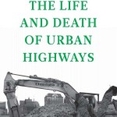](http://www.scribd.com/doc/88708771/The-Life-and-Death-of-Urban-Highways)**  
“While the following report is about urban highways, more importantly, it is about cities and people. It is about **community vision** and the **leadership required in the twenty-first century** to overcome the **demolition, dislocation, and disconnection of neighborhoods caused by freeways in cities**.”[**The Life and Death of Urban Highways (Institute for Transportation & Development Policy and EMBARQ, 2012)**](http://www.scribd.com/doc/88708771/The-Life-and-Death-of-Urban-Highways)

TxDOT’s plan includes more than 2 miles of elevation:

**[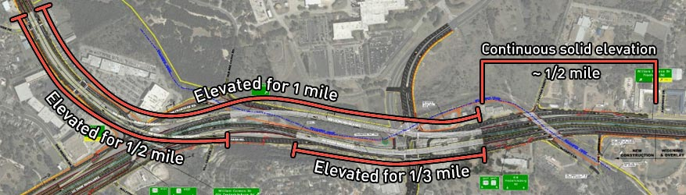](http://www.saveoakhill.org/wp-content/uploads/2015/05/elevation.jpg)**

“Long segments of elevated alignments cause **greater aesthetic and neighborhood disruption** than do at-grade (surface) alignments.”  
– [***Indianapolis Northeast Corridor Transportation Study, Marion and Hamilton Counties***](http://www.indympo.org/SiteCollectionDocuments/www.indympo.org/PDF/tempose_summer_00.pdf)

**Why Are They The Wrong Choice?**

* **Blight**: “Land directly below an elevated freeway is not easily visible to the public and can be **a haven for undesirable or criminal activities**.” – [***Rethinking the Urban Freeway, Mayors Innovation Project, 2013***](http://www.ssti.us/wp/wp-content/uploads/2013/12/SURDNA_freeway-brief.pdf)
* **Noise Pollution**: “Perhaps the most problematic roadways in urban areas are elevated highways because (1) it may be **difficult to introduce some mitigation measures** on these roads, and (2) they have a greater potential for visual blight.” – [***“The Built Environment and Public Health”***](http://www.amazon.com/The-Built-Environment-Public-Health/dp/047062003X)*, Russell P. Lopez, Jossey-Bass; 2 edition (January 3, 2012), Page 78*
* **Decreased Property Values**: “Planners, policymakers, and legislators must look at **noise damage costs**caused by motor vehicles when considering transportation options” – [***Factors that Determine the Reduction in Property Values Caused by Traffic Noise, Road Engineering Journal***](http://www.usroads.com/journals/p/rej/9710/re971004.htm)
* **Bad for Business**: Obscured store-fronts, increased signage costs, and more difficult access. “**At-grade construction was found to have the most positive impact**on commercial property values” – [***Impact of Highways on Property Values, Prepared for Arizona Department of Transportation***](http://ntl.bts.gov/lib/24000/24800/24842/AZ516.pdf)
* **Shadow Effect on Vegetation**: …”the objections that Hudson anticipated to the **‘obtrusiveness and darkening effect’** of the elevated roadway, which he quantified by the length of shadow it would cast at different times of day.” – [***“Concrete Utopia: The Development of Roads and Freeways in Los Angeles, 1910”***](https://books.google.com/books?id=VlD1SU3Xd2wC&pg=PA151&lpg=PA151)*, Matthew William Roth, May 2007, Page 151*
* **Barrier effect**: Elevated highways are “**a significant visual and psychological barrier**” – *Seattle Department of Transportation Director Grace Crunican*
* **More Expensive to Build and Maintain**: “Elevated structures typically **cost three to four times as much**.”– [***Indianapolis Northeast Corridor Transportation Study, Marion and Hamilton Counties***](http://www.indympo.org/SiteCollectionDocuments/www.indympo.org/PDF/tempose_summer_00.pdf)
* **More Susceptible to Inclement Weather**: “One of the most dangerous types of road icing threats comes from bridges and overpasses. A bridge is exposed to air on all of its surfaces – on top, underneath and on its sides.” – [***Icy Bridges: Taking Drivers by Surprise***](http://icyroadsafety.com/icybridges.shtml)

TxDOT’s plan for the 4.5 miles of elevated toll road through Oak Hill is estimated to cost **729 million dollars**. That’s $162 million per mile and one of the most expensive projects in the 2040 plan.  
– [***CAMPO 2040 Plan, Chapter 5, Pages 168-9***](http://www.campotexas.org/wp-content/uploads/2015/10/CAMPO2040PlanFinal_Chpt5_LowRes.pdf)

**How Elevated Highways Have Hurt the City of Dallas**

**For all of the talk about the Texas miracle, there has been one big loser: Dallas.**

Shocking, right? Yet every metric shows our urban core in decline. Our tax base shows weakness. We’re losing jobs. Household income is down. Property taxes are up.

How did this happen?

There are a number of explanations, but near the top of the list are the highways that cut through the center of our urban core. These highways, created for truckers and commuters in the 1960s, destroyed Dallas neighborhoods, wiped out local commerce, and left in their wake empty lots, filled with detritus. In the 1960s, roughly 60 percent of the region’s population resided in Dallas. Dallas was the region. Today the city houses only 17 percent of the total population.

**Dallas’ voice is muted in the matter. So is yours. So is the Mayor’s. So is the City Council’s. All these decisions come from bureaucrats, who have all but ignored local interests over the years.**

**So here’s the rub: Local leadership, going back to Mayor Erik Jonsson, has tried to prevent highways from being built through our city, but to no avail.**  
That’s because there is no process in place to stop the process. All these decisions come from bureaucrats, who have all but ignored local interests over the years. They hold perfunctory town-hall meetings, hear out local citizens and leaders, and then charge ahead—building and repairing highways—regardless of how it affects Dallas citizens. It’s time we took back our city and determined our own future.

**Highways are not the bad guys. Elevated interstate highways running through the middle of cities are.**

They reduce land values and discourage investment. The battle over I-345 presents an opportunity for Dallas to uncover and unleash the billions in value that lie underneath and around our aging elevated highways, to repopulate our southern sector, and to rebuild our tax base.

Interstates were originally meant to connect cities, not run through them; yet, we have three elevated interstates running through the heart of our city. Mayor Rawlings says that 55 percent of this traffic does not originate or stop in the City of Dallas. So why do we have them at all?

We have them because traffic engineers and highway builders in the 1960s and 1970s did not understand how cities work. Like the urban renewal projects of the time, which razed neighborhoods in order to save them, the elevated highways were considered progress. Their mission was to produce mobility and speed for city residents. Today, highway engineers seem honestly befuddled as to why their highways instead produce snarls and congestion.

**Interstates were originally meant to connect cities, not run through them; yet, we have three elevated interstates running through the heart of our city. Mayor Rawlings says that 55 percent of this traffic does not originate or stop in the City of Dallas. So why do we have them at all?**

Here’s the thing about traffic. It’s a simple law of economics. If you make something easy and free, you will get more of it.

The elevated interstates that were rammed through downtown Dallas made trucking a long-haul load through the city easy and free. It made commuting from a job in one suburb to a home in another suburb easy and free. So the citizens of Dallas got more traffic, and they got nothing in return except for depressed land values and a reduced tax base in return.

It’s no surprise, then, that aside from the a few great civic projects and the development of Main Street, downtown Dallas seems to move in slow motion. The reason is that our city looks from the air as if it is hung on a concrete noose. In the meantime, Dallas County has lost 215,000 jobs in the last 11 years. Dallas is ranked 27th in growth last year among major American cities.

You can't ignore all that road noise: It could shorten your life

By [LISA MULCAHY](http://www.latimes.com/health/la-he-road-noise-20160109-story.html#nt=byline)

JAN 09, 2016 | 8:00 AM

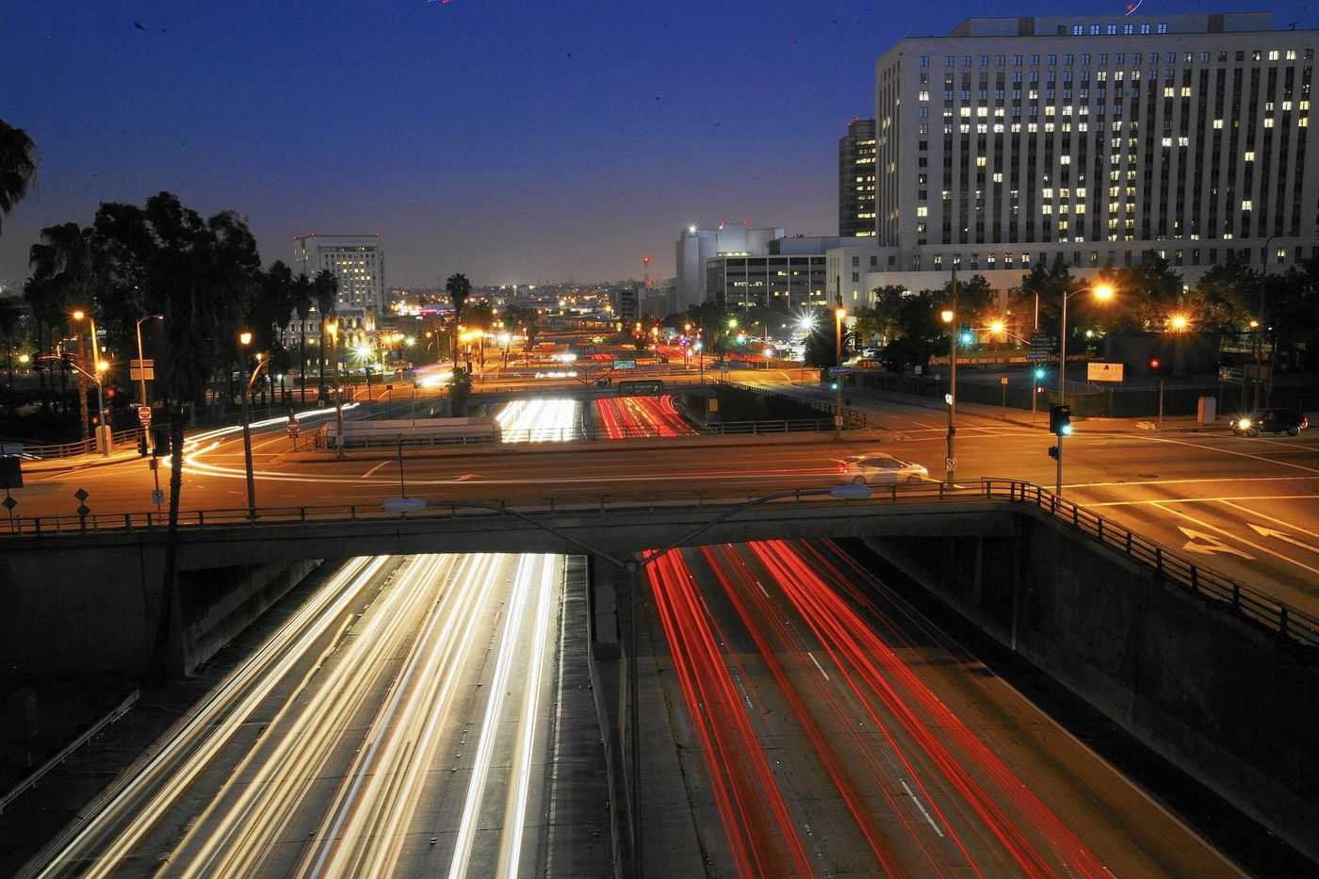

A view over the 101 Freeway southbound from the Hill Street bridge. (Francine Orr / Los Angeles Times)

Living in a city like Los Angeles means being exposed to honking horns, revving engines and loud traffic on a pretty much constant basis. You know this; what you might not know is that living in the vicinity of road noise, or spending too much time on the noisy freeway, might be endangering your health. New international research is shedding light on the unique problems that this kind of noise pollution can present:

•Researchers at the London School of Hygiene & Tropical Medicine in partnership with Imperial College London and King's College London found that long-term exposure to moderately loud or very loud traffic sounds during the daytime — the kind you'd experience after months to years of city dwelling — contributed to the risk of a shorter life expectancy. "In this study, we observed that the risk of death from any cause was increased by 4% in areas with noise level over 60 decibels when compared to quieter areas," said study co-author Jaana Halonen. "Risk of death from ischemic heart disease was also increased by 3% in adults and 4% in the elderly in areas with daytime noise levels of 55-60 decibels, when compared to areas with noise levels under 55 decibels."

The researchers believe this happens because traffic noise can cause spikes in blood pressure and increased levels of stress hormones such as cortisol and noradrenaline, which can increase stress and sleep problems.

And all of these factors can raise your risk of cardiovascular conditions.

A new study by Swedish researchers, published in the journal Occupational & Environmental Medicine, found that being immersed on a daily basis in road noise — as well as noise from a nearby airport or rail station — can widen your waistline. Sixty-two percent of subjects regularly exposed to 45 decibels or higher of road, airport or rail noise had a 25% to 50% larger waist measurement than those not exposed to this noise. The researchers also found that road, airport and rail noises increase the body's production of the stress hormone cortisol, which affects metabolism.

Ongoing research by Danish scientist Mette Sorensen indicates that people 65 or older who live in high road noise areas were 27% more likely to suffer a stroke; what's more, Sorensen believes her results could indicate that up to 19% of all stroke cases could be due in whole or part to traffic noise. The damage is cumulative — the longer you live near the noise, the higher your stroke risk. Interestingly too, Sorensen found the main factor contributing to these strokes is Type 2 diabetes. Her findings indicate this is because road noise lowers one's ability to get quality sleep, which causes decreased glucose tolerance.

So is it time to move?

Keep the research in perspective, experts say. Individual responses to road noise is not universal.

"For some people, daily exposure to road noise may not be so stressful — these people can habituate to that stress effect much better than others," says Dr. Emeran Mayer, professor and director of the Oppenheimer Family Center for Neurobiology of Stress at UCLA. "Their brains may be more resilient in that way. Other people, especially those whose genetic makeup may predispose them to obesity, for example, may experience health problems due to road noise stress."

If road noise has your nerves on edge, and especially if you have risk factors for obesity, heart disease, stroke or diabetes, you can take action to reduce the impact.

**Four ways to reduce the effects of road noise:**

**Muffle the sound at home.** Consider whether freeway noise might be seeping into your house in unexpected ways. "Houses and apartments also have exhaust vents, attic vents, unsealed construction joints, electrical outlets and other openings which are 'weak links' for the transmission of noise," says David Lord, a principal at 45dB Acoustics Consulting, who works throughout the greater L.A. area. "As soon as you seal one avenue for noise transmission, the remaining openings become more obvious, so they all have to be dealt with for the best solution." (One tip: Lord recommends laminated glass as an exterior noise barrier for windows, as it can reduce noise levels by as much as 10 decibels.)

**Breathe.** "Abdominal breathing — breathing with the diaphragm, in the abdomen instead of breathing in the chest — signals to the brain to go into a relaxed state," says UCLA's Dr. Emeran Mayer. You can practice this kind of breathing any time you're stuck in traffic.

**Distract your ears.** Lord is a fan of white noise. "There's an iPhone app for $2 — and I can switch to pink noise, blue noise, or a mountain stream or rainstorm or surf ... the variations are endless," he says. Also, listen to any kind of music you love during a noisy commute. Research shows it reduces stress responses.

**Live healthfully.** Eating a healthful diet rich in fruits and vegetables can help lower the risk of heart problems, strokes and diabetes. Also, exercise 30 minutes a day, five times a week, for the same preventive reason.

[*health@latimes.com*](mailto:health@latimes.com)

A view over the 101 Freeway southbound from the Hill Street bridge. (Francine Orr / Los Angeles Times)

**Living Near Highways and Air Pollution**

Being in heavy traffic, or living near a busy road, may be risky compared with being in other places in a community. Growing evidence shows that pollution levels along busy highways may be higher than in the community as a whole, increasing the risk of harm to people who live or work near busy roads.

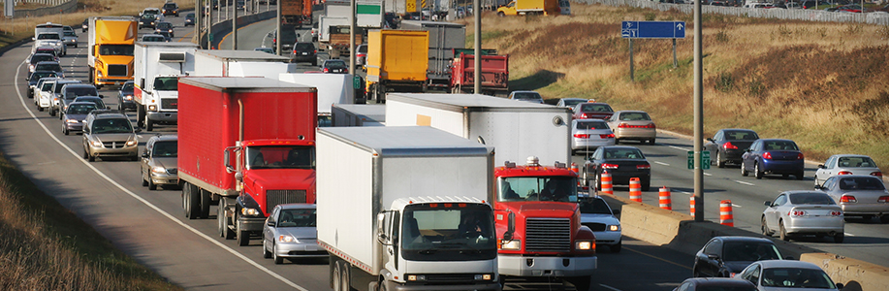

The number of people living "next to a busy road" may include 30 to 45 percent of the urban population in North America, according to the most recent review of the evidence. In January 2010, the Health Effects Institute published a major review of the evidence put together by a panel of expert scientists. The panel looked at over 700 studies from around the world, examining the health effects of traffic pollution. They concluded that traffic pollution causes asthma attacks in children, and may cause a wide range of other effects including: the onset of childhood asthma, impaired lung function, premature death and death from cardiovascular diseases and cardiovascular morbidity. The area most affected, they concluded, was roughly the band within 0.2 to 0.3 miles (300 to 500 meters) of the highway.1

Children and teenagers are among the most vulnerable—though not the only ones at risk. A Danish study found that long-term exposure to traffic air pollution may increase the risk of developing chronic obstructive pulmonary disease (COPD). They found that those most at risk were people who already had asthma or diabetes.2 Studies have found increased risk of premature death from living near a major highway or an urban road.3Another study found an increase in risk of heart attacks from being in traffic, whether driving or taking public transportation.4Urban women in a Boston study experienced decreased lung function associated with traffic-related pollution.5

Adults living closer to the road—within 300 meters—may risk dementia. In 2017, a study of residents of Ontario, Canada, found that those who lived close to heavy traffic had a higher risk of dementia, although not for Parkinson’s disease or multiple sclerosis. Researchers found the strongest association among those who lived closest to the roads (less than 50 meters), who had never moved and who lived in major cities.6 A study of older men in 2011 also found that long-term exposure to traffic pollution increased their risk of having poor cognition.7

* Sources

**News & Events**

* **News:**[**Wildfire Smoke Continues to Blanket California, Pacific Northwest**](http://www.lung.org/about-us/media/press-releases/wildfire-smoke-continues-to-blanket-ca-pacnw.html)
* **News:**[**Lung Association Applauds Senate’s Vote Rejecting Resolution to Block Safeguards from Oil and Gas Industry Methane Venting, Flaring and Leaking**](http://www.lung.org/about-us/media/press-releases/ALA-BLM-Methane-CRA-Statement.html)
* **Blog:**[**Space Travel Obstacles?**](http://www.lung.org/about-us/blog/2016/01/space-travel-obstacles.html)
* **Blog:**[**Deadly December Smogs to Remember and Prevent**](http://www.lung.org/about-us/blog/2016/12/deadly-december-smogs.html)

*Reviewed and approved by the American Lung Association Scientific and Medical Editorial Review Panel. Last reviewed February 10, 2018.*

[**Our Initiatives**](http://www.lung.org/our-initiatives/)

**Business owners suffering from U.S. 19 construction seek relief from state**

*By*[*Tracey McManus*](mailto:tmcmanus@tampabay.com)**Published: November 21, 2015**

**Updated: November 22, 2015 at 01:28 AM**

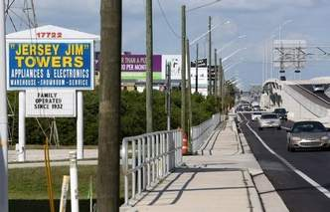

*Photos by MONICA HERNDON | Times*

The entrance to “Jersey Jim” Towers Appliances and Electronics is along a frontage road parallel to U.S. 19 in Clearwater. Drivers have to exit well before they can see the store for best access.

CLEARWATER — It wasn't the economic recession or market competition that caused sales at Jim Towers' appliance store to plummet more than 50 percent over the past six years, he says.

He believes it was the reconstruction of U.S. 19, which permanently eliminated the direct turn drivers took from the highway into his parking lot. Now customers heading south on the elevated highway have to watch for the Belleair Road exit, before the store is even in sight, and drive along a frontage road to reach him. If they miss the exit, their next chance to get off U.S. 19 isn't for another half-mile past Towers' store, which means winding through a "nightmare" loop of U-turns to get back on the highway.

"People were avoiding us because they couldn't get here," said Towers, whose appliance repair and retail business has been at the same location for 22 years. "For the first time I had to let (employees) go. Before all this I had four sales people. Now I'm down to one. That's how much business has dropped."

State law does not provide any recourse for business or property owners who have lost profits as a result of a Florida Department of Transportation project unless they had property taken through eminent domain. Businesses that had portions of their parking lots taken, for example, can sue for damages.

But places like Jersey Jim Towers TV and Appliances, which never had land taken but allege the restructuring has devastated his business, have had no legal remedy.

Now, some Clearwater business owners are trying to change that.

Perkins Restaurant and Bakery owner Ed Lechner said he plans to ask the state Legislature to create a compensation fund to reimburse businesses that have lost customers as a result of the U.S. 19 reconstruction.

"It's the little people that are being hurt here," said Lechner, a retirement plan lawyer who opened the Perkins on the corner of Gulf to Bay Boulevard and U.S. 19 in 1978. "The only people who can help us here are the governor and the legislators."

Lechner is proposing a compensation fund modeled after the BP settlement that paid damages to businesses affected by the 2010 Deepwater Horizon oil spill. Businesses would submit evidence of losses during the construction period and would receive reimbursement from the state.

The DOT did not respond to questions regarding the impact U.S. 19 reconstruction has had on businesses.

Lechner's plan would require a legislator to sponsor a bill backing the fund. On Thursday, about 20 business owners gathered at the Perkins to unveil Fight19.org, a website to solicit testimonies from disenfranchised businesses to present to the Pinellas County legislative delegation.

Rep. Kathleen Peters, R-South Pasadena, chair of the delegation, said in an interview that while the impact on businesses has been real, a compensation fund may not be the answer.

"I'm not sure a fund like that is the way to go," she said. 'I think you have to look at what the local government's responsibility is," such as installing signs to direct drivers to businesses on the frontage lanes.

Paul Boudreaux, professor of law at Stetson University, said state law on business damages does not allow for payouts when land wasn't taken because it would "open up a Pandora's box of liability" for the government.

He said it's nearly impossible to avoid impacts of infrastructure enhancement projects, and it would be difficult to build anything if the DOT had to pay every citizen facing an inconvenience.

"One of the policy rationales is the government helps businesses all the time," he said. "If a government puts in a new road or a new bridge, the government doesn't get compensation for that."

The DOT began the intensive restructuring of U.S. 19 in the 1970s to build overpasses and frontage lanes, making much of it a signal-free, limited access highway.

The original reconstruction plan stretched from Gandy Boulevard in St. Petersburg to the Pasco County line, and the project was divided into segments over the decades.

Crews broke ground on the 2 ½-mile, $116 million project from Whitney Road to State Road 60 in Clearwater in 2009. The original completion date was 2013, but a series of setbacks — from weather delays to concrete discovered buried in the corridor — pushed completion to 2015.

Lechner said these delays could have been prevented and put an undue burden on surrounding businesses.

For nearly six years, drivers had to dodge orange barrels and battle closed lanes while construction was completed.

Lechner said his sales plummeted more than 25 percent as regular customers avoided the highway. For the first time in almost four decades of business, he had to lay off employees and invest $60,000 of his own money to keep the franchise afloat.

"If this project was in front of Disney World, it wouldn't have taken from 2009 to 2015 to get it done," he said. "We haven't been treated fairly in Pinellas County."

St. Petersburg-based lawyers Jim Helinger Jr. and Tobyn De- Young said they have represented hundreds of property owners in Tampa Bay over the past three decades in litigation against the DOT for the devaluation of property as a result of the U.S. 19 project.

DeYoung said in the beginning, the DOT initiated frequent eminent domain proceedings, opening the door for property owners to sue. But in the early 2000s, the DOT began using more existing right of way, leaving property owners and businesses with fewer opportunities to sue.

"Their project put businesses out of business, put people out of work and destroyed the value of these properties and all they're concerned about is building their road as cheaply as possible," De- Young said.

In the past 18 months alone, DeYoung and Helinger have tried and won four lawsuits against the DOT that have resulted in a total of nearly $10 million in settlements for property owners along U.S. 19. But almost all of their cases involved properties that had been through eminent domain, not businesses that did not experience taking of land.

"What they are asking for is not unfair," DeYoung said. "There is no way to rationalize what's happening to these businesses. … Unfortunately, we're bound by court decisions and the current law."

*Contact Tracey McManus at tmcmanus@tampabay.com or (727) 445-4151. Follow @TroMcManus.*

   
 

**NEWS**

**Controversial Bonita Springs intersection study stalls**

A controversial study about traffic at a busy Bonita Springs intersection will not move forward. The Metropolitan Planning Organization voted today to stop the study at US-41 and Bonita Beach Road.

Friday, August 22nd 2014

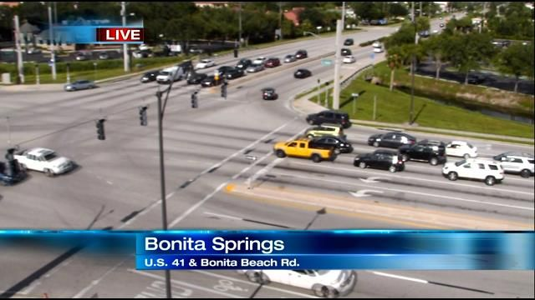

A controversial study about traffic at a busy Bonita Springs intersection will not move forward.

The Metropolitan Planning Organization voted today to stop the study at US-41 and Bonita Beach Road, which has been going back and forth for months. Some city leaders are worried traffic at the intersection is too congested, as well as about what a solution might do to local businesses.

Drivers at US-41 and Bonita Beach Road will not get relief any time soon from a congested intersection.

"Estero is not going to stop growing. North Naples is not going to stop growing. Bonita is not going to stop growing," said Bonita Springs Mayor Bill Nelson.

Board members for the Metropolitan Planning Organization voted to stop a controversial Florida Department of Transportation study to relieve traffic at the intersection.

FDOT started the study earlier this year, but residents rallied against it. They feared a flyover would not be good their small town and hurt local business.

"Overpasses and six lane roads just destroy our state," said Deborah Maclean, Bonita Springs resident.

Fred Forbes, also a Bonita Springs resident said he thinks it's the right decision. "I think it gives everybody time to figure out what we want to do and figure out what we want the vision for Bonita Beach Road to be," he said.

Others called the decision a short-sighted mistake.

According to FDOT, the study would consider a flyover but would also include other options - like adding more lanes. Those are options Bill Nelson said the city could implement to fix the traffic problem. You get information before you make the decision - you don't make the decision before you get the information," said Mayor Bill Nelson.

Bonita Springs City Council voted to recommend FDOT stop the study at a meeting last month - but the MPO had the final say. Nelson said Friday's decision sets the city's traffic planning back ten years and will only create a traffic nightmare in the future. "The council right now doesn't feel the need, because they think traffic is OK. Wait until it gets bad. But then it's a little late," he said.

As far as what's next for this intersection, city leaders say there is no plan right now. Some residents said they'd like the city to come up with its own study to find a solution that would not involve a flyover option.

Road Engineering Journal Copyright © 1997 by

Factors that Determine the Reduction in

Property Values Caused by Traffic Noise

Environmental noise caused by traffic can reduce property

values. Planners, policymakers, and legislators must look at

noise damage costs caused by motor vehicles when considering

transportation options. Daniel Haling and Harry Cohen

provided a method to estimate this type of noise impact in

"Residential Noise Damage Costs Caused by Motor Vehicles"

(Transportation Research Record 1559).

**BACKGROUND**

The majority of sounds detected by human hearing are within

the range of 0 to 140 decibels (dB). The noise created by traffic

normally resides in the range of 50 to 95 dB. The effects of

transportation noise are routinely measured using an Aweighted

decibel scale (designated dBA), which is useful for

measuring the noise impact of a single occurrence but not the

impact of continuous noise. A frequently used measurement for

continuous noise is the equivalent sound level (Leq), known

also as the energy mean sound level. Leq includes both the

intensity and length of all sounds occurring during a given

period; it indicates "the average acoustic intensity over time and

is the equivalent noise energy level of a steady, unvarying tone."

The Environmental Protection Agency has developed a

measurement for a community's exposure to noise (the average

energy sound level) for a 24-hour period from midnight to

midnight. The measure of this day-night sound level, designated

DNL or Ldn, is commonly used to evaluate noise impacts on

communities and residential areas.

**NOISE PREDICTION MODEL / NOISE DAMAGE COST**

**STUDIES**

The most common model for estimating vehicle traffic noise

levels is the Federal Highway Administration's (FHWA's)

STAMINA 2.0/OPTIMA. Derived from long-standing research

by the FHWA and the National Cooperative Highway Research

Program (NCHRP), the FHWA model "is a two-level coordinate

system-based program, based on energy-equivalent sound

levels."

Studies in the 1970s "estimated that background noise in a

typical urban neighborhood was roughly 55 Ldn and that

housing prices decreased by 0.2 to 0.6 percent for every one

unit increase in Ldn." A major study of noise costs conducted

for the 1982 Federal Cost Allocation Study "assumed a 0.4

percent decrease in the value of a housing unit for each dBA

(Leq) increase over a threshold value of 55 dBA."

**NOISE COST CALCULATIONS**

Calculating the impact of transportation noise on residential

property values requires constructing a model for estimating the

value of property that includes an estimate of traffic noise cost.

One method for calculating noise impact cost is based on an

estimating procedure developed in 1981 and used in the 1982

Federal Highway Cost Allocation Study. This procedure takes

into consideration reduced residential property values caused by

noise from vehicles. It operates on the theories that people will

pay to avoid high noise levels and that housing values reflect

location relative to a noisy roadway.

The procedure for estimating noise damage uses three main

components: (1) the number of housing units affected, (2) the

noise level in decibels above an established noise threshold, and

(3) the average change in property values per decibel that can

be attributed to the roadway. The number of housing units

affected varies by location. The noise emission level of vehicles

changes depending on the type of vehicle, its speed, its

operating weight, and the volume of traffic on the roadway. The

third component of the calculation is constant for all housing

units, based on a survey of studies on residential property

values affected by noise. Using these values, the noise damage

caused by each vehicle-kilometer can be calculated--subject to

the type of vehicle, its speed, the volume of traffic on the

roadway, and the type of housing development surrounding the

roadway.

**TRANSPORTATION NOISE LEVEL**

Calculating the noise damage cost of a single vehicle requires

estimating the noise emission of that vehicle, as well as the

noise emission of all vehicles on that segment of road. Noise

emission level estimates of single vehicles are based on two

emission equations developed by the FHWA--the first for large

trucks and the second for passenger cars and light trucks. Truck

noise levels, which are significantly different from those

generated by passenger cars, are converted into noise passenger car

equivalents (NPCEs) using factors developed through a

vehicle emission equation and a total noise level equation.

By combining transportation noise levels across vehicle

classes, a composite noise emission level for the roadway is

produced. (It should be noted that decibels add logarithmically

rather than algebraically.)

The number of housing units affected by transportation noise

depends on the density of the housing population and how close

the housing unit is to the roadway. Noise distance ranges are

estimated for each of the land development types shown in

Table 1 below. The distance ranges are an estimated number of

feet within which houses are subject to a given noise level

range. Three noise levels are established at 55-65 dBA, 65-75

dBA, and greater than 75 dBA. The noise distance ranges are

labeled A, B, and C, where C is closest to the roadway and

assumed to begin at 9.14 m (30 ft), with no housing units

located closer than that to the roadway.

After noise distance ranges are estimated, housing densities

are needed to calculate the total number of housing units

affected. Based on the 1981 noise cost study, Table 1 illustrates

the housing densities per acre by land development type and

noise distance range. As noted earlier, previous noise impact

studies estimated that housing units lose 0.4 percent of their

value for every decibel above the threshold level. The most

recent survey of housing values (1993) showed a median house

value of $86,529. Using this value annualized at a 10 percent

discount rate and multiplied by the 0.4 value loss, the noise

damage cost is found to be $34.61 per decibel per housing unit.

**NOISE DAMAGE COSTS PER VEHICLE MILE**

Noise damage costs can be calculated per vehicle-mile for

each land development type, traffic volume range, and vehicle

speed. Noise damage costs reflect the number of housing units

the vehicle affects and the number of decibels the vehicle adds

to the existing traffic noise.

Table 2 shows the noise damage cost per NPCE-mile for each

land type and traffic speed, based on average annual daily

traffic (AADT). The table shows that, in all land-development

categories, noise damage costs increase as traffic speeds

increase. Similar results occur in urban areas devoted to

residential use; as traffic speed increases, the damage costs per

NPCE mile increase. However, as traffic volumes increase, the

noise damage contributed by a single vehicle decreases. For

example, at a traffic speed of 55 mph, the noise damage costs

decrease from 0.25 cents per NPCE mile to 0.16 cents as traffic

increases from 10,000- to 200,000-NPCE AADT.

Table 2: Noise Damage Costs per NPCE-Mile

Noise damage costs can also be estimated for a variety of

truck types and operating weights. Costs will vary depending on

the land development type. For example, a five-axle semitrailer

operating at 65,000 pounds and traveling in an urban business

district will cause 5.74 cents of noise damage per vehicle mile.

In an urban fringe area, the cost will increase to 11.48 cents per

vehicle mile.

**CONCLUSIONS**

Motor vehicle types, traffic volumes, and land development

types surrounding roadways all play significant roles in

estimating residential noise damage costs. Those responsible for

transportation planning and policymaking should be aware of

the variations in these costs and the three primary factors that

define them.