**Healthy Air**

[www.lung.org](http://www.lung.org/) > [Our Initiatives](http://www.lung.org/our-initiatives/) > [Healthy Air](http://www.lung.org/our-initiatives/healthy-air/) > [Outdoor](http://www.lung.org/our-initiatives/healthy-air/outdoor/) > [Air Pollution](http://www.lung.org/our-initiatives/healthy-air/outdoor/air-pollution/)

**Living Near Highways and Air Pollution**

Being in heavy traffic, or living near a busy road, may be risky compared with being in other places in a community. Growing evidence shows that pollution levels along busy highways may be higher than in the community as a whole, increasing the risk of harm to people who live or work near busy roads.

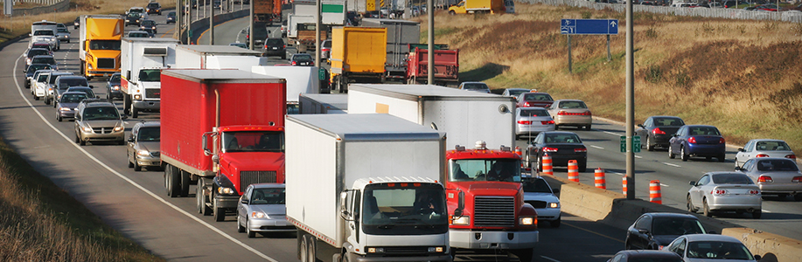

The number of people living "next to a busy road" may include 30 to 45 percent of the urban population in North America, according to the most recent review of the evidence. In January 2010, the Health Effects Institute published a major review of the evidence put together by a panel of expert scientists. The panel looked at over 700 studies from around the world, examining the health effects of traffic pollution. They concluded that traffic pollution causes asthma attacks in children, and may cause a wide range of other effects including: the onset of childhood asthma, impaired lung function, premature death and death from cardiovascular diseases and cardiovascular morbidity. The area most affected, they concluded, was roughly the band within 0.2 to 0.3 miles (300 to 500 meters) of the highway.1

Children and teenagers are among the most vulnerable—though not the only ones at risk. A Danish study found that long-term exposure to traffic air pollution may increase the risk of developing chronic obstructive pulmonary disease (COPD). They found that those most at risk were people who already had asthma or diabetes.2 Studies have found increased risk of premature death from living near a major highway or an urban road.3Another study found an increase in risk of heart attacks from being in traffic, whether driving or taking public transportation.4Urban women in a Boston study experienced decreased lung function associated with traffic-related pollution.5

Adults living closer to the road—within 300 meters—may risk dementia. In 2017, a study of residents of Ontario, Canada, found that those who lived close to heavy traffic had a higher risk of dementia, although not for Parkinson’s disease or multiple sclerosis. Researchers found the strongest association among those who lived closest to the roads (less than 50 meters), who had never moved and who lived in major cities.6 A study of older men in 2011 also found that long-term exposure to traffic pollution increased their risk of having poor cognition.7

* Sources
  1. Health Effects Institute Panel on the Health Effects of Traffic-Related Air Pollution, *Traffic-Related Air Pollution: A Critical Review of the Literature on Emissions, Exposure, and Health Effects.* Health Effects Institute: Boston, 2010. Available at [www.healtheffects.org](http://www.healtheffects.org/).
  2. Andersen ZJ, Hvidberg M, Jensen SS, Ketzel M, Loft S, Sørensen M, Tjønneland A, Overvad K, and Raaschou-Nielsen O. Chronic Obstructive Pulmonary Disease and Long-Term Exposure to Traffic-related Air Pollution: A Cohort Study. *Am J Respir Crit Care Med.*2011; 183: 455-461.
  3. Finklestein MM, Jerrett M., Sears M.R. Traffic Air Pollution and Mortality Rate Advancement Periods. *Am J Epidemiol.* 2004; 160: 173-177; Hoek G, Brunkreef B, Goldbohn S, Fischer P, van den Brandt. Associations between mortality and indicators of traffic-related air pollution in the Netherlands: a cohort study. *Lancet.* 2002; 360: 1203-1209.
  4. Peters A, von Klot S, Heier M, Trentinaglia I, Cyrys J, Hormann A, Hauptmann M, Wichmann HE, Lowel H. Exposure to Traffic and the Onset of Myocardial Infarction. *N Engl J Med.*2004; 351: 1721-1730.
  5. Suglia SF, Gryparis A, Schwartz J, and Wright RJ. Association between Traffic-Related Black Carbon Exposure and Lung Function among Urban Women. *Environ Health Perspect.*2008;116 (10): 1333-1337.
  6. Chen H, KJC, Capes R, et al. Living near major roads and the incidence of dementia, Parkinson’s disease and multiple sclerosis: a population-based cohort study. *Lancet*. 2017. Published online <http://dx.doi.org/10.1016/5014-6736(16)32596-X>.
  7. Power MC, Weisskopf MG, Alexeeff SE, et al,. Traffic-related air pollution and cognitive function in a cohort of older men. *Environ Health Perspect*2011*;*119:682–687. doi:10.1289/ehp.1002767