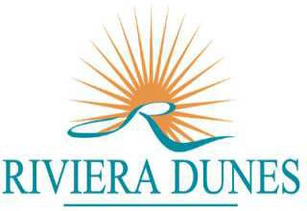RIVIERA DUNES MASTER ASSOCIATION INC. 

May 10, 2022 at 10am

<https://meet.goto.com/908974805>

**Phone:** (571) 317-3122

**Access Code:** 908-974-805

**Password:** 220510

1. Call to Order
2. Establish Quorum
3. Proof of Notice
4. Approval of Minutes – January 5, 2022
5. President’s Report
6. Treasurer’s Report
7. Committee Reports
8. Unfinished Business
9. New Business
   * Appointment of Committee Members
     + ARC
     + Legal Liability
     + Security
     + Bridge
   * RD Sign Repair
   * Landscape Maintenance
   * Ratification of Proposals
     + Hardy Outdoor
   * Proposals for Consideration
     + Natural Designs Landscaping- Enhancements to 3 Monument Signs
     + GoToMeeting Renewal
     + Dog Waste Stations
10. Owner Comments
11. Adjournment